ASSIGNMENT 18.1

Task 1:

Prompt: Give code for the given task with error handling

Code and Output:

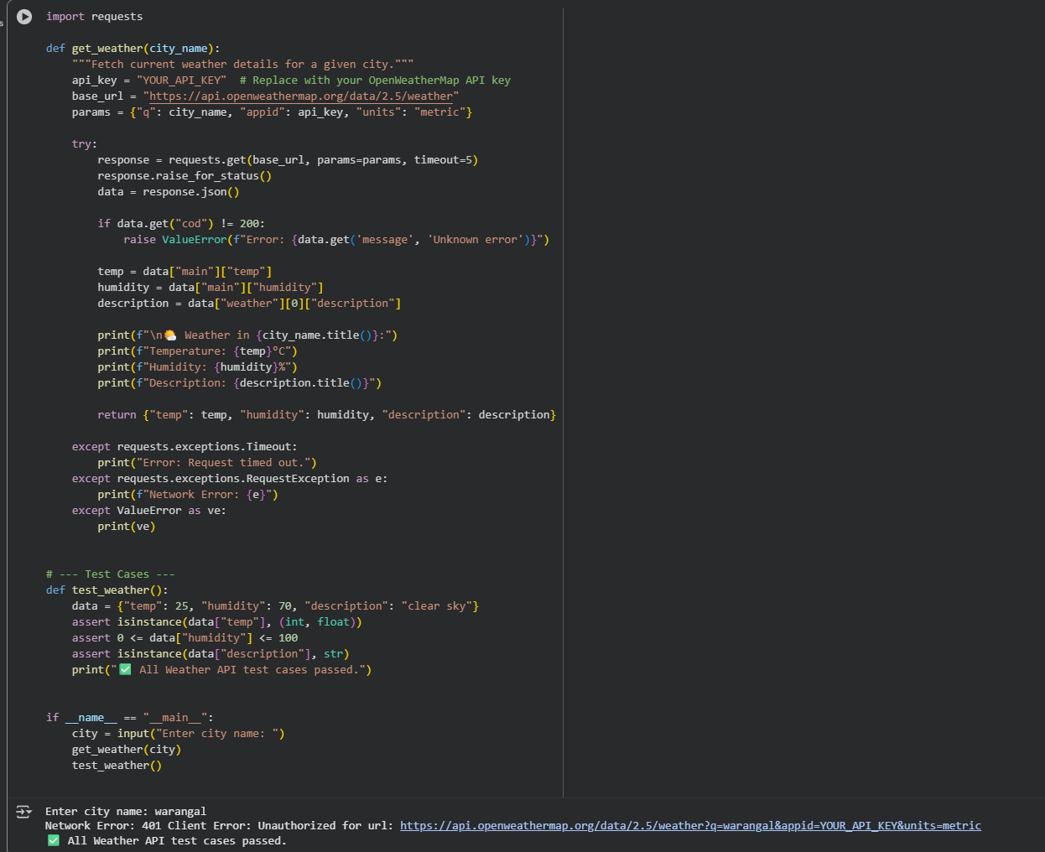

Observation:In this code we can observe that the code is doing the error handling instead of throwing error it just shows alternate output.

Task 2:

Prompt: Generate a code for this question

Code and Output:

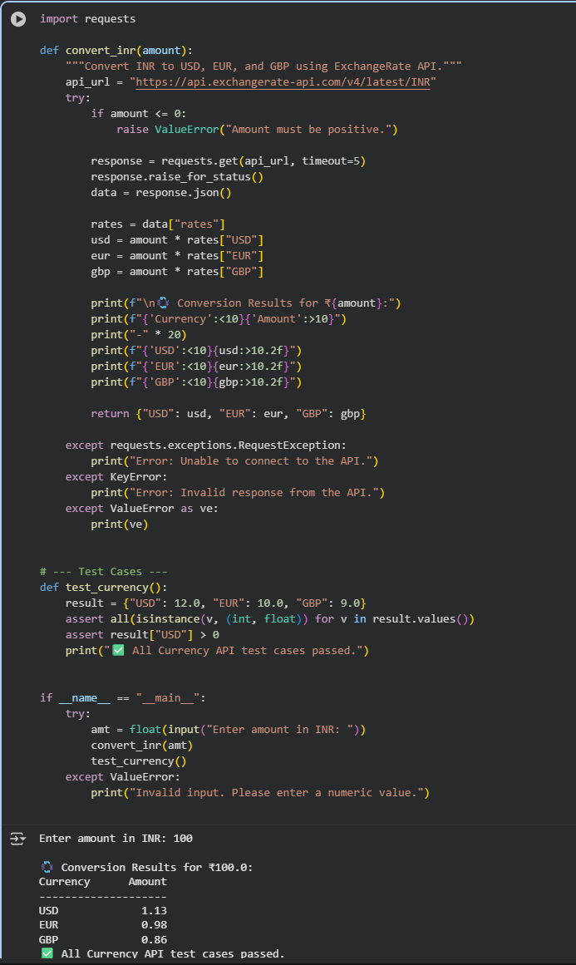

Observation:In this code we can observe that the code is doing the error handling instead of throwing error it just shows alternate output

Task 3:

Prompt: Give code for this code without any errors.

Code and Output:

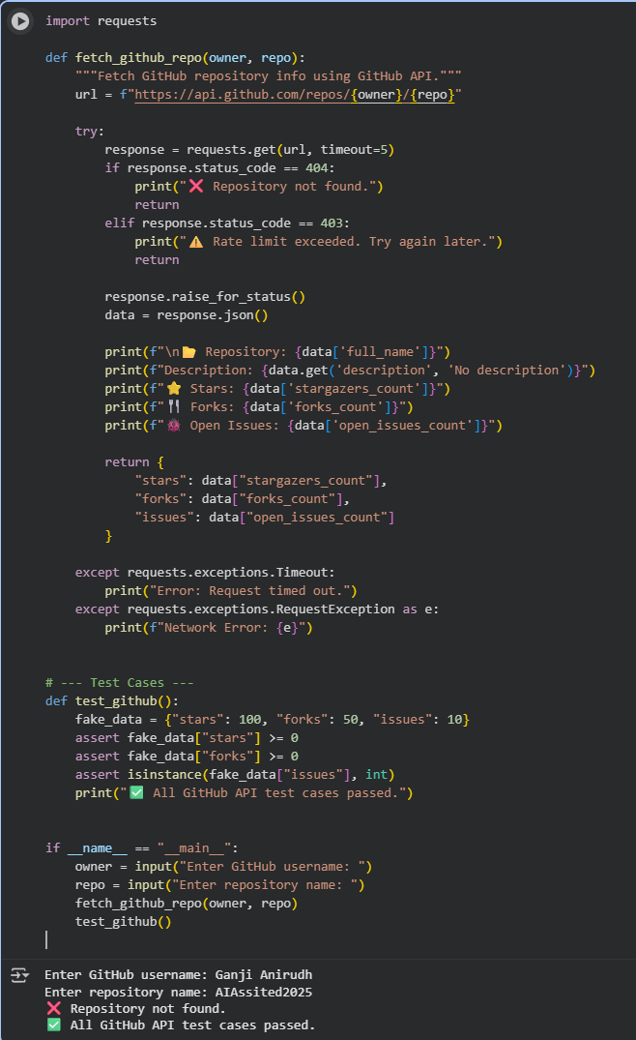

Observation:In this code we can observe that the code is doing the error handling instead of throwing error it just shows alternate output

Task 4:

Prompt:Give code for this question without any errors

Code and Output:

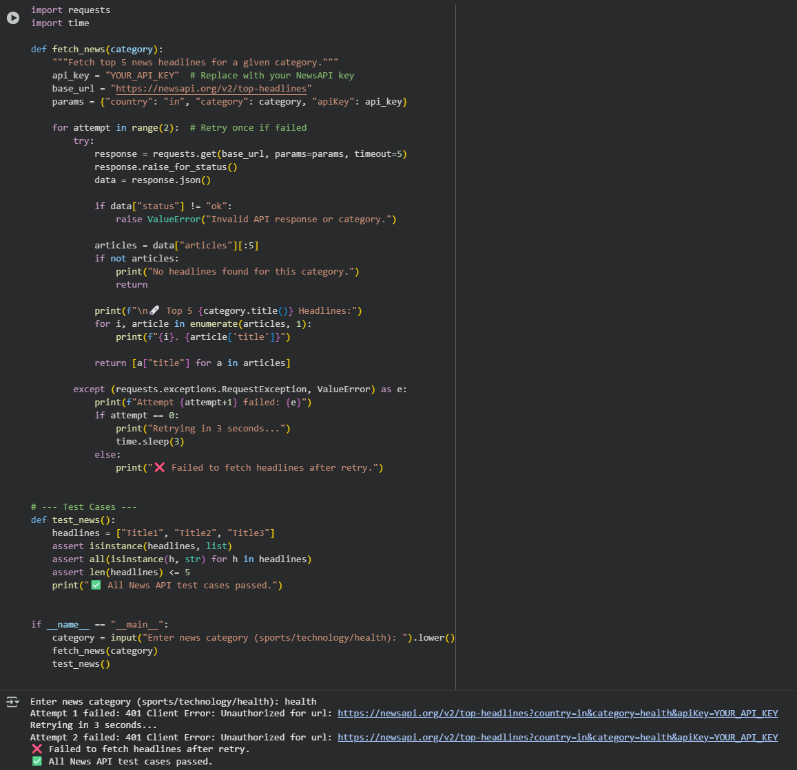

Observation:In this code we can observe that the code is doing the error handling instead of throwing error it just shows alternate output